
..0

Year 8 Science 2018 Name: _____________
Biology 2 Test: Systems

SECTION 1: MULTIPLE CHOICE (1 mark each)
Circle your answer on the multiple choice answer sheet.

- What makes up most of the volume of blood?
  - red blood cells
  - white blood cells
  - platelets
  - plasma

- The trachea belongs to which system?
  - respiratory
  - reproductive
  - excretory
  - circulatory

- A component of the heart that prevents the reverse flow of blood is called the:
  - vena cava
  - right atrium.
  - atrioventricular valve.
  - aorta.

- The name of the biological catalyst that increases the rate of chemical reaction without being used up is called:
  - an acid.
  - a red blood cell.
  - a platelet.
  - an enzyme.

- Which statement is true?
  - The majority of gas exchange in humans occurs in the mouth.
  - The majority of gas exchange in humans occurs in the alveoli.
  - The majority of gas exchange in humans occurs in the rib cage.
  - The majority of gas exchange in humans occurs in the trachea.

- The part of the digestive system that produces bile (a chemical that helps break down fats and oils), stores and releases blood sugars and breaks down alcohol is the:
  - stomach
  - large intestine
  - anus
  - liver

- Blood sugar levels are regulated by the hormone:
  - insulin
  - small intestine
  - platelets
  - enzymes

- Blood pressure is measured by using a:
  - anemometer
  - thermometer
  - barometer
  - sphygmomanometer

- Which part of the digestive system is responsible for the storage and concentration of bile?
  - gallbladder
  - liver
  - pancreas
  - stomach

- Which type of blood cell has haemoglobin within its structure?
a) leucocytes
b) thrombocytes
c) erythrocytes
d) plasma

Biology 2 Body Systems Test

SECTION 1: Multiple Choice Answers

Circle your selection

- A B C D

- A B C D

- A B C D

- A B C D

- A B C D

- A B C D

- A B C D

- A B C D

- A B C D

- A B C D

Multiple choice: ____ / 10 Marks

SECTION 2: WRITTEN
Write your answers in the spaces provided.

- Label the following diagram of the heart (3 marks)

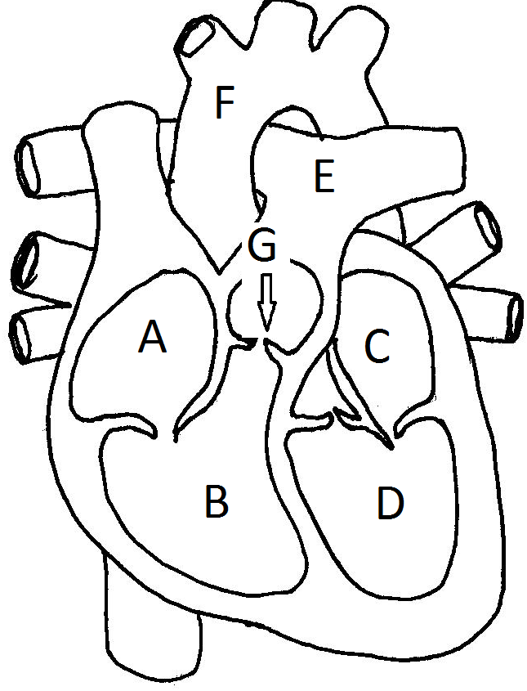

A - __________________

B - __________________

C - __________________

D - __________________

E - __________________

F - __________________

G - __________________

2. Label the following diagram of the digestive system (4 marks)
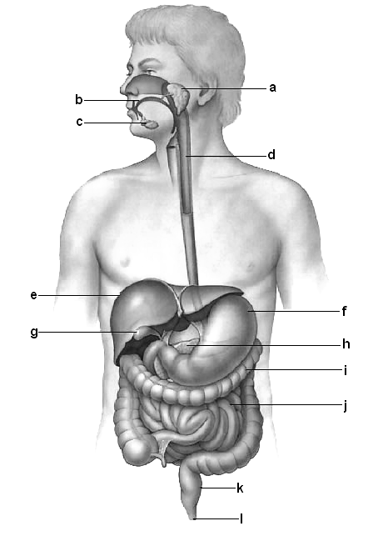

b - ___________________

d - ___________________

e - ___________________

f - ____________________

i - ___________________

j - ___________________

k - _________________

l - _________________

3. Label the following diagram of the respiratory system (5 marks)

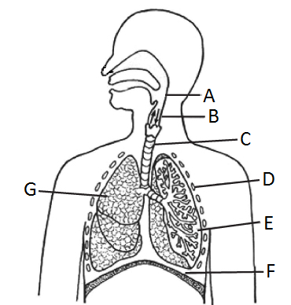

C - ______________________

D - ______________________

E - ______________________

F - ______________________

G - ______________________

Section 2: _____ / 12 Marks

END OF TEST

TEST TOTAL: _____ / 22 Marks

